**5 Climbing Mistakes to Avoid as a New Climber**

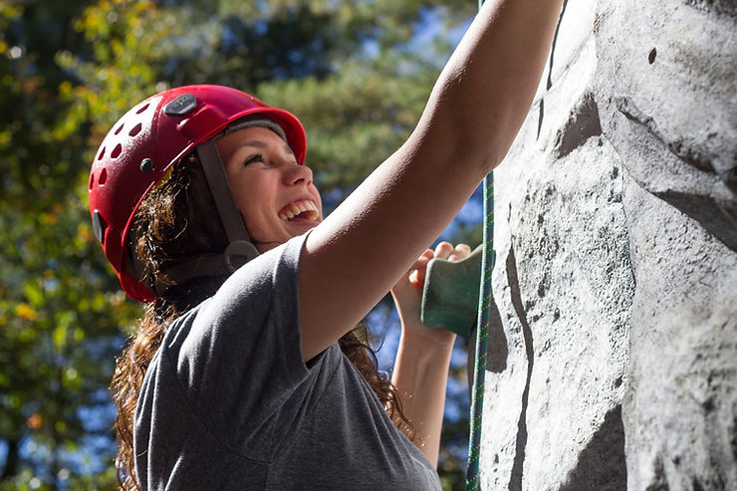

Climbing is one of the most exhilarating experiences you can have, but this excitement may turn into a tragedy due to a simple mistake that could have been avoided.

Part of avoiding these mistakes is knowing that they exist in the first place. That’s why if you’re a new climber, it’s important that you familiarize yourself with all the risks instead of jumping straight into the sport or trying to tackle a wall that is over your skill level.

To help keep yourself and your climbing partner safe, we list a few common climbing mistakes and how to avoid them.

**1. Not Double Checking Your Knots**

Before you even begin climbing, you want to double-check your knots. Make sure they are tied correctly, are tightened enough, and that they are completely threaded through your harness. Once you’ve checked your own harness, have your partner double-check over you, and then do the same for them.

If you don’t do this there is a chance that [your rope](https://sportrock.com/rope-maintenance-and-care/) could come loose and cause you serious injury.

**2. Your Arms are Bent/Strained**

Climbing with your arms slightly bent can provide you with a little more power, but it can also strain your arms and cause them to tire out much more quickly. Do yourself a favor and climb with your arms straight.

This position lets you rest on your body’s skeletal structure thereby decreasing muscle strain. When your body is flatter and closer to the wall you put less weight on your arms. This way you don’t tire as quickly.

**3. Don’t Go Over Your Ability**

When you’re climbing with a partner that’s more experienced than you, they may try to get you to climb walls that are way above your ability level. It’s important that you don’t let them do this.

Climbing uses muscles that are not commonly used, increasing the risk of injury. Common issues from going over your ability are finger, arm, and shoulder injuries.

Finger injuries happen because our extensor tendons typically are not as strong as our flexors. As a result, finger tendon injuries are more likely if you try to go over your climbing capabilities.

Even though it can be tempting because you want to show off or try something new, [going over your limits](https://www.psychologytoday.com/us/collections/201203/know-your-limits) can be dangerous and cause serious injury.

**4. Not Wearing a Helmet**

Anything can happen while you’re climbing. For example, you could slip on a loose rock and hit your head on the wall, or flip upside down and again hit your head. That’s why it’s important that you wear a [proper helmet](https://www.rush.edu/health-wellness/discover-health/helmet-safety-keep-lid-it).

You might feel silly wearing a helmet but it’s better than facing possible injury.

**5. Only Looking Up**

Some climbers make the mistake of only looking up while they climb. Many inexperienced climbers tend to look for the next handhold rather than checking their feet placements.

By not paying attention to where you are placing your feet, you could exert more energy than is actually needed.

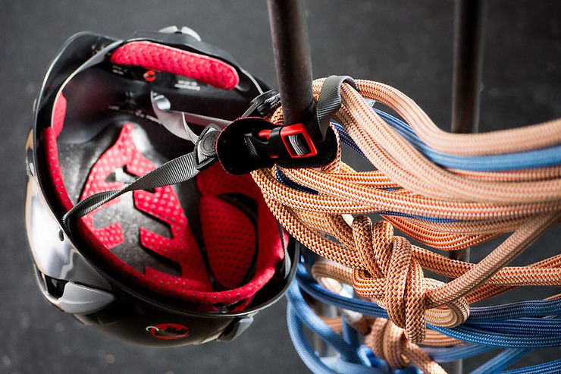

**Learning Never Stops in Climbing**

When you’re a new climber it can be tempting to go full force into a difficult climb, forget to wear a helmet, or not pay attention to where you are placing your feet. These are very simple mistakes that could quickly lead to tragedy. But a bigger mistake is complacency. Even if you become really good at the sport, it's important to learn new things that will keep yourself and your partner injury-free. Also, never forget or overlook repetitive safety measures that might seem trivial or time-consuming. Your life depends on them.

Remind or educate whoever you climb with that safety is always first. Even if you know how to keep yourself safe, if your partner doesn’t, you can still get severely injured.